2007 Ford Mustang GT

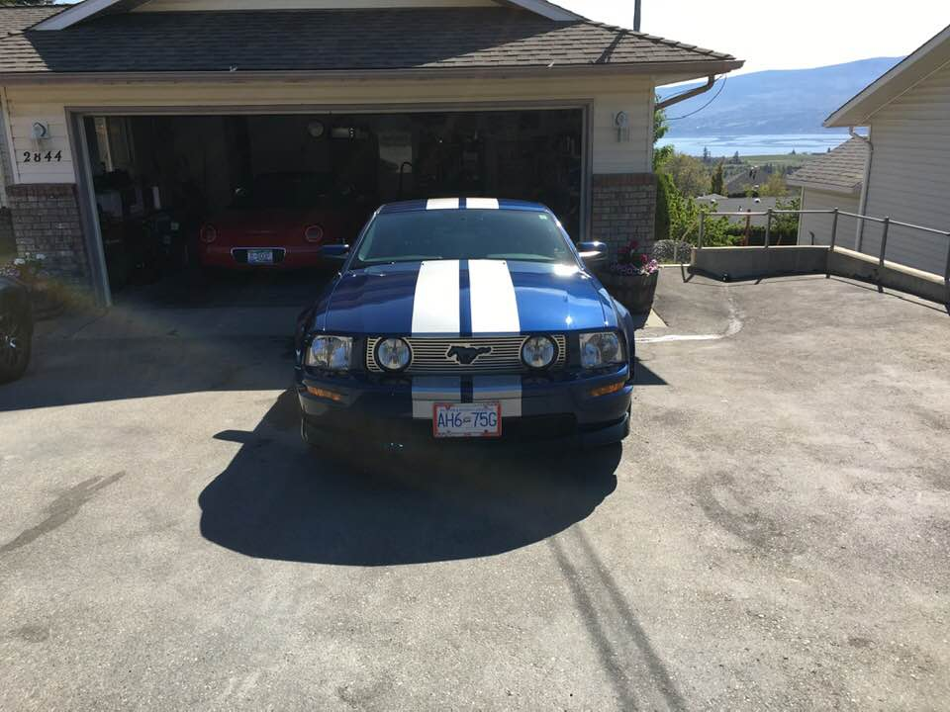

$17,500.00 F I R M Price
Factory Colour G9 Vista Blue - Titanium Silver Racing Stripe
VIN 1ZVFT82H1753362615

75.514 miles or 123, 138 Km ** No accident record.

Modification List
* Shorty Antenna
* Strut Mount Covers (nuts)
*Hood Struts
* Shifter Chrome
* Shifter Trim Bezel
* Chrome A/C Knobs
* MGW Electrical GT Plug
* Chrome Mirror Control Knob
* Locking Gas Cap
* Satin Finish Outer Fuel Door
* Sequential Taillights
* Chrome Headlights
* Painted G9 Mirror Covers
*Sylvania H13 replacement bulbs
* White Map Light Bulb Replacement
* Lamin-X Headlight Covers
* Chrome Overlay Billet Grille Cover
* Painted Pony Grille Moulding
* Black Mustang Horse Molding (Door Pillars)
* Tri - Bar Pony fender emblems
* Urethane Front Splitter
* Foam & Rubber Trunk Mat
* 4 BF Goodrich G- Super Sport tires April 2015
* Cover Craft Spacer Mesh Seat Covers (Blue & Black)
*New rear deck badge
*4 Touren TR60 Wheels
*MAXX cross & drilled black rotors - May 2017
* Blue painted calipers
*Roush CAI Kit
* Brenspeed SCT Tuner
*Roush Door inserts
* Flowmaster Thunder Mufflers.
*Pony Puddle Lights
*Billet Engine Caps
*Satin Fuse Box Cover with Tri-Bar Pony Emblem
*Rear side window louvers
*Kenwood Bluetooth Sync AM/FM CD Stereo - May 2016
*New rear deck GT badge.
* Radiator cover extensions.
* Blended paint (G9) on front hood and Satin Silver stripe repair correction of left
side. New clearcoat.

* Blended paint (G9) on right rear quarter panel. New clearcoat.
* New window moldings driver and passenger door window sill.
* Rear Deck Chrome Billet (Seat Anchor Covers).
* Door Speaker Chrome Covers.
* Mustang Cup Holder Lights
* Canada Energy Battery (2018).
* Champion Double Platinum Spark Plugs 7989. ( Spark Plug change May 2018).
* Mud flaps.
* Blue Oval Industries Strut Tower Brace Bar.

** Oil Change & filter - Valvoline Full Synthetic 5w-20w - August, 2018
** Transmission Fluid and Filter Change - 13 September, 2018
** Alignment October 2019.
** Meguiar's DA Microfiber Swirl & Scratch Removal Process April 2019

